Prepare a prediction model for profit of 50_startups data.

Do transformations for getting better predictions of profit and make a table containing R^2 value for each prepared model.

R&D Spend -- Research and devolop spend in the past few years

Administration -- spend on administration in the past few years

Marketing Spend -- spend on Marketing in the past few years

State -- states from which data is collected

Profit -- profit of each state in the past few years

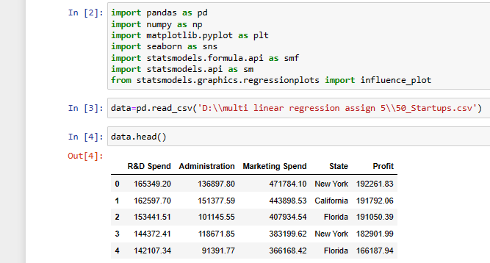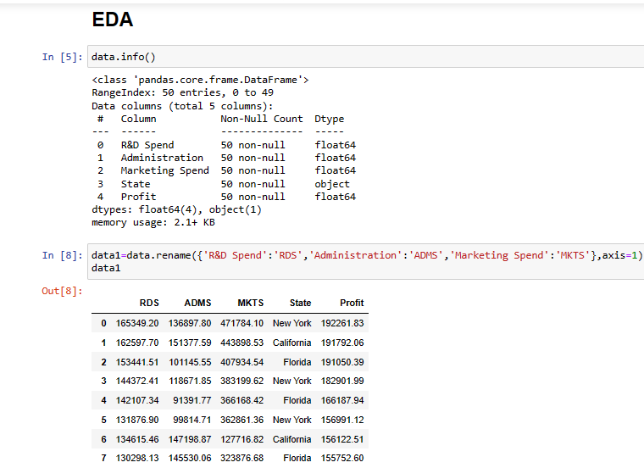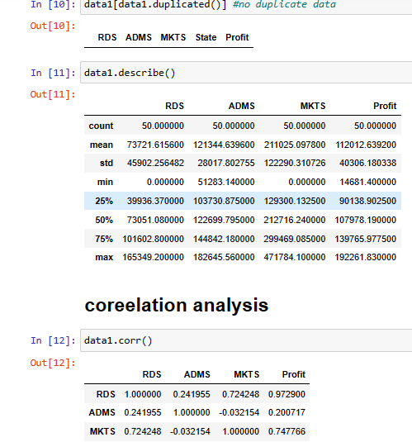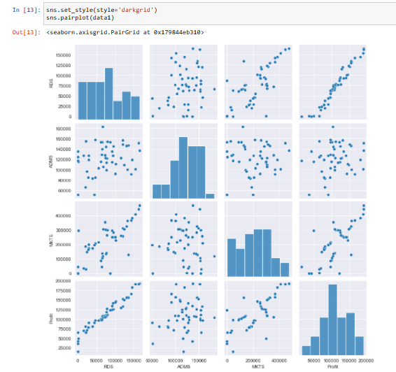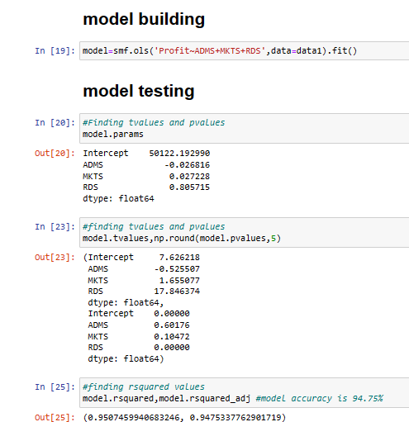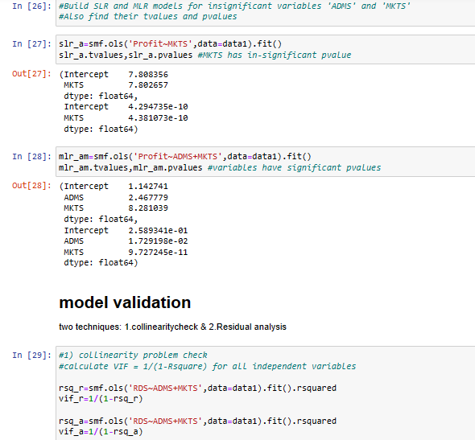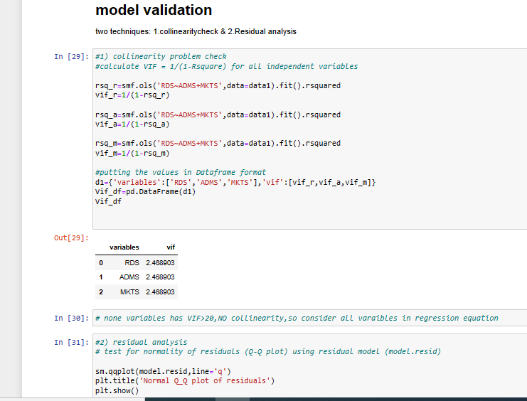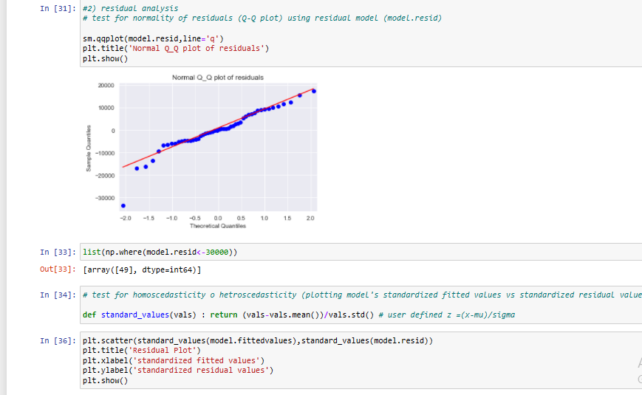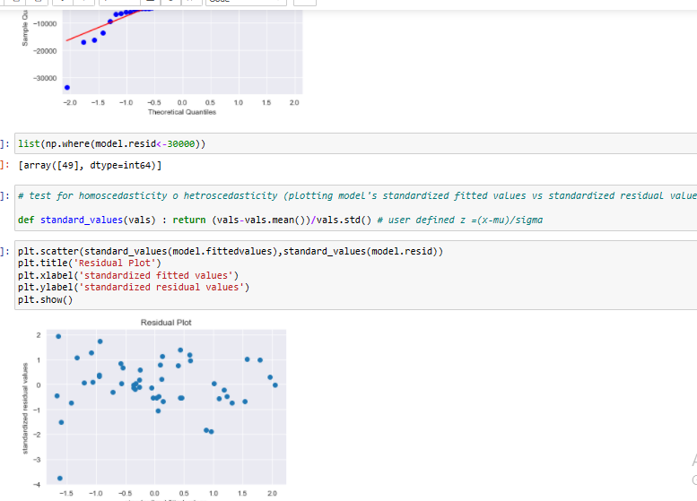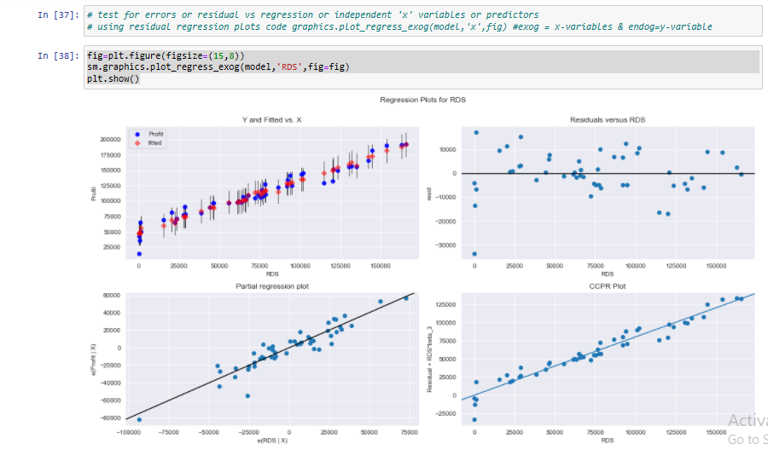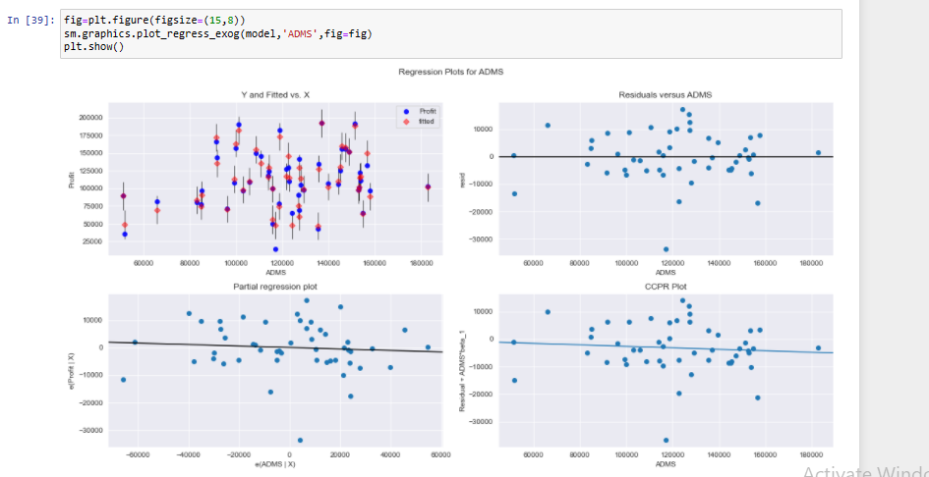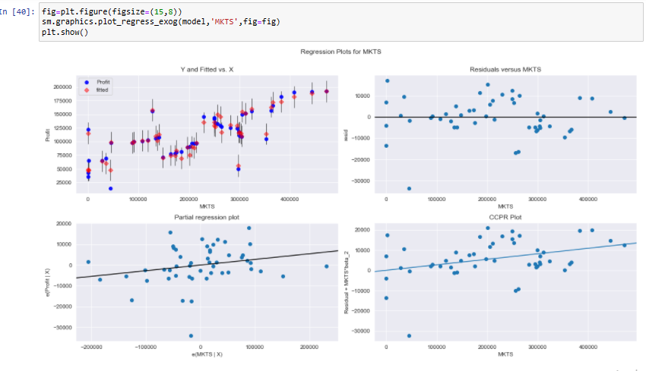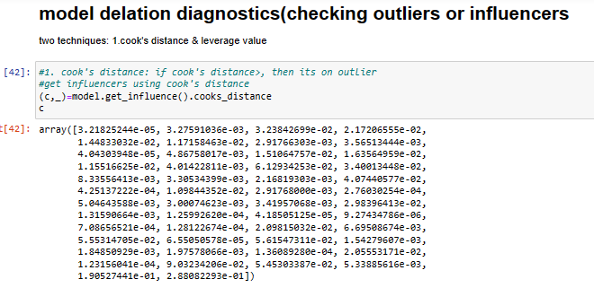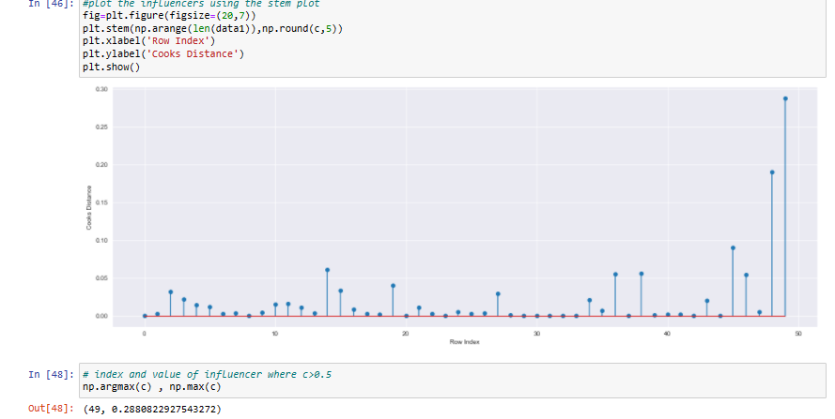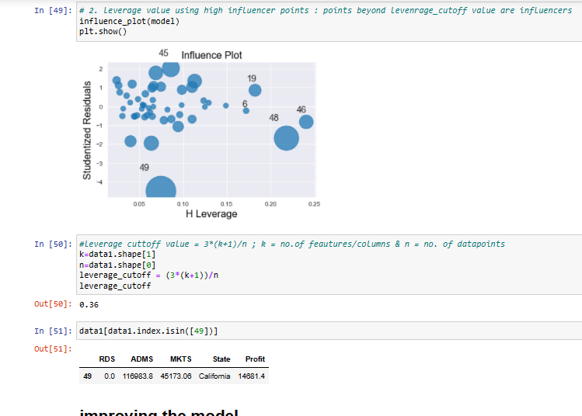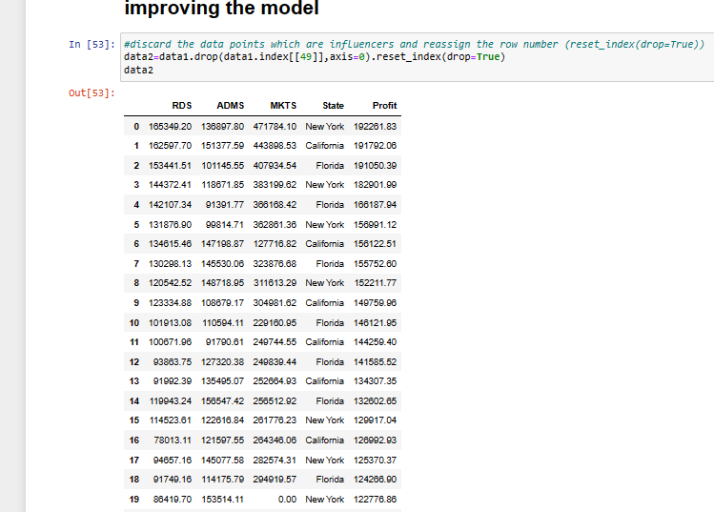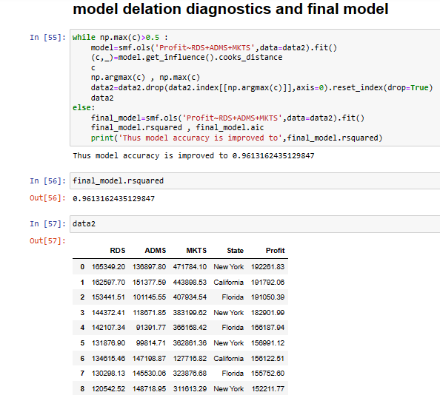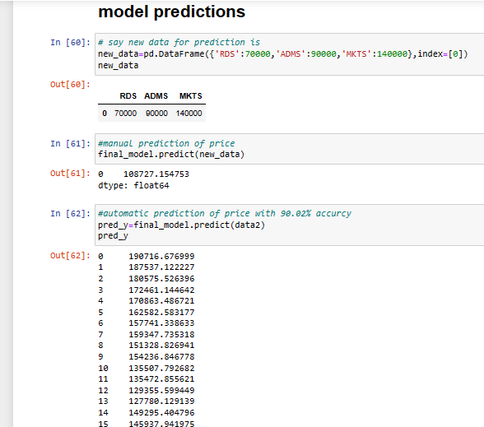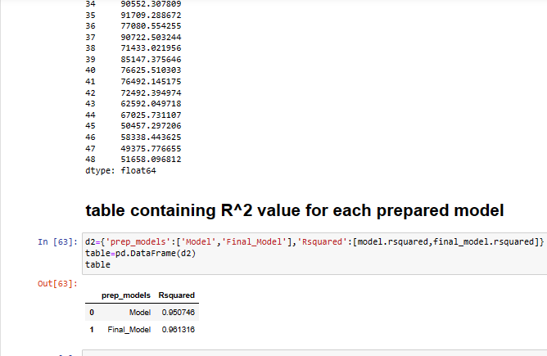

Consider only the below columns and prepare a prediction model for predicting Price.

Corolla<-Corolla[c("Price","Age_08_04","KM","HP","cc","Doors","Gears","Quarterly_Tax","Weight")]

Model -- model of the car

Price -- Offer Price in EUROs

Age_08_04 -- Age in months as in August 2004

Mfg_Month -- Manufacturing month (1-12)

Mfg_Year -- Manufacturing Year

KM -- Accumulated Kilometers on odometer

Fuel_Type -- Fuel Type (Petrol, Diesel, CNG)

HP -- Horse Power

Met_Color -- Metallic Color? (Yes=1, No=0)

Color -- Color (Blue, Red, Grey, Silver, Black, etc.)

Automatic -- Automatic ( (Yes=1, No=0)

cc -- Cylinder Volume in cubic centimeters

Doors -- Number of doors

Cylinders -- Number of cylinders

Gears -- Number of gear positions

Quarterly_Tax -- Quarterly road tax in EUROs

Weight -- Weight in Kilograms

Mfr_Guarantee -- Within Manufacturer's Guarantee period (Yes=1, No=0)

BOVAG_Guarantee -- BOVAG (Dutch dealer network) Guarantee (Yes=1, No=0)

Guarantee_Period -- Guarantee period in months

ABS -- Anti-Lock Brake System (Yes=1, No=0)

Airbag_1 -- Driver_Airbag (Yes=1, No=0)

Airbag_2 -- Passenger Airbag (Yes=1, No=0)

Airco -- Airconditioning (Yes=1, No=0)

Automatic_airco -- Automatic Airconditioning (Yes=1, No=0)

Boardcomputer -- Boardcomputer (Yes=1, No=0)

CD_Player -- CD Player (Yes=1, No=0)

Central_Lock -- Central Lock (Yes=1, No=0)

Powered_Windows -- Powered Windows (Yes=1, No=0)

Power_Steering -- Power Steering (Yes=1, No=0)

Radio -- Radio (Yes=1, No=0)

Mistlamps -- Mistlamps (Yes=1, No=0)

Sport_Model -- Sport Model (Yes=1, No=0)

Backseat_Divider -- Backseat Divider (Yes=1, No=0)

Metallic_Rim --Metallic Rim (Yes=1, No=0)

Radio_cassette -- Radio Cassette (Yes=1, No=0)

Tow_Bar -- Tow Bar (Yes=1, No=0)

